Dear Stranger is a statewide letter-exchange project that Humanities Nebraska modeled after a program by the same name at Oregon Humanities, Dear Stranger encourages people to reflect on their experiences and beliefs and make new connections by writing letters to strangers: write a letter, get a letter, and make a new connection.
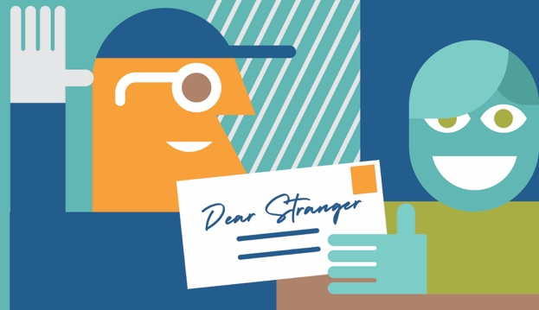
How it works:
The theme is place. The following prompt is offered:
In this time of social distancing, some of us have longed to go places or have reminisced about places we’ve been. Perhaps you are proud of the place you live or the place you and your family have come from, or are drawn to a place you often visit or hope to visit in the future. Interpret the theme as broadly as you are inspired to do. Because place is often about experiencing a location, consider sharing a postcard, photo, or artistic expression of the place you write about with your letter.

Instructions for Participants:
1. Write a letter addressed to “Dear Stranger.” Letters can be as short or long as a writer likes (even a postcard).

2. Mail your letter and signed participant form to “Dear Stranger,” c/o Humanities Nebraska, 215 Centennial Mall South Ste 330, Lincoln, NE 68508 by February 28, 2021. Anyone, of any age, may participate, and to do so anonymously should they choose. We also ask participants to complete the participation form indicating their understanding that Humanities Nebraska is not responsible for the content of letters and that, if they are under 18 or younger, they have a parent or guardian’s permission to participate. This is a one-to-one exchange; each writer receives the letter written by the person who receives theirs. All letters are screened for offensive content and we may, with permission, publish letters or excerpts on our website.

3. If a participant wants to respond to the Dear Stranger letter they received, we ask them to include a return address in the body of their reply and mail it to us so we can send it on to the person they were paired with. If they would also like to continue correspondence, the parties can continue their exchange directly.

Questions about Dear Stranger? Please email DearStranger@humanitiesnebraska.org or visit our website and click on “Dear Stranger” under programs.

Support for Dear Stranger has been provided by Postscript (Ashland, Nebraska).

